A MAJOR PROJECT REPORT

ON

**“Prepaid Energy Meter with GSM Technology using LabVIEW**”

***Submitted in partial fulfillment for the award of the degree***

Of

**BACHELOR OF TECHNOLOGY**

IN

**ELECTRONICS AND COMMUNICATION ENGINEERING**

***Submitted By:***

**NAKKA KISHORE KUMAR (12R21A04F9)**

**G.SUSHMA (13R25A0412)**

**K. CHANDANA (12R21A0490)**

Under the Supervision of

**HARI BABU**



**MARRI LAXMAN REDDY INSTITUTE OF ETCHNOLOGY**

**(Affiliated to Jawaharlal Nehru Technological University Hyderabad)**

**HYDERABAD**

**2016**

**MARRI LAXMAN REDDY INSTITUTE OF TECHNOLOGY**

**DEPARTMENT OF ELECTRONICS AND COMMUNICATION ENGINEERING**



***CERTIFICATE***

This is to certify that the project work entitled **Prepaid Energy Meter with GSM Technology using** **LabVIEW** has been submitted in partial fulfillment of the requirement for the award of degree of Bachelor of Technology in **Electronics & Communication Engineering** discipline of JNTU, Hyderabad for the academic year 2016 is a record bonafide work carried out by

**NAKKA KISHORE KUMAR (12R21A04F9)**

**G.SUSHMA (13R25A0412)**

**K. CHANDANA (12R21A0490)**

**Signature of the guide Signature of the Head of the Department**

**Mr. HARI BABU Mr.S.V.S.PRASAD**

**External Examiner Principal**

**Acknowledgement**

With the completion of the project, we would like to thank all the people involved in the work.

We are grateful to principal of **Marri Laxman Reddy Institute Of Technology**, for granting the permission for the practical training through development of this project. We shall forever cherish our association with him for exuberant encouragement ,inspiration and motivation given throughout.

We wish to express our sincere thanks to **Mr.S.V.S Prasad, Head of the Department, Electronics & Communication Engineering**, for guiding us all through our project provoking discussions, invigorating suggestions extended to us with an immense care and zeal.

We have immense pleasure in expressing our thanks and deep sense of gratitude to our guide, **Mr.Hari Babu** for his guidance and assistance offered in an aim able and pleasant manner throughout our project.

We sincerely thank to all the teaching and non-teaching staff of the Department of Electronics & Communication Engineering for their timely suggestions, healthy criticism and motivation during the course of this work.

**NAKKA KISHORE KUMAR (12R21A04F9)**

**G.SUSHMA (13R25A0412)**

**K. CHANDANA (12R21A0490)**

**DECLARATION**

We hereby declare that this major project report entitled ‘**Prepaid Energy Meter with GSM Technology using** **LabVIEW’** has been prepared by us, in partial fulfillment of the requirements for the award of Bachelor of Technology in Electronics & Communication Engineering.

We also declare that this work is a result of our own effort and that it has not been submitted to any other university for the award of any Degree/Diploma.

**NAKKA KISHORE KUMAR (12R21A04F9)**

**G.SUSHMA (13R25A0412)**

**K. CHANDANA (12R21A0490)**

**CHAPTER-1**

**Aim:**

With a growing population, we must all be smarter with the resources we have. The aim of the project is to minimize the queue at the electricity billing counters and to restrict the usage of electricity automatically, if the bill is not paid. To provide customers Speed, Convenience (No contracts, no monthly bills) and accessibility.

**INTRODUCTION:**

**LabVIEW** (short for Laboratory Virtual Instrumentation Engineering Workbench) is a platform and development environment for a visual programming language from National Instruments. The graphical language is named "G". Originally released for the Apple Macintosh in 1986, LabVIEW is commonly used for data acquisition, instrument control, and industrial automation on a variety of platforms including Microsoft Windows, various flavors of UNIX, Linux, and Mac OS X. The latest version of LabVIEW is version LabVIEW 2015. Visit National Instruments at www.ni.com. The code files have the extension “.vi”, which is an abbreviation for “Virtual Instrument”.

**Graphical Programming:**

LabVIEW ties the creation of user interfaces (called front panels) into the development cycle. LabVIEW programs/subroutines are called virtual instruments (VIs). Each VI has three components: a block diagram, a front panel, and a connector panel. The last is used to represent the VI in the block diagrams of other, calling VI’s Controls and indicators on the front panel allow an operator to input data into or extract data from a running virtual instrument. However, the front panel can also serve as a programmatic interface. Thus a virtual instrument can either be run as a program, with the front panel serving as a user interface, or, when dropped as a node onto the block diagram, the front panel defines the inputs and outputs for the given node through the connector pane. This implies each VI can be easily tested before being embedded as a subroutine into a larger program.

**CHAPTER-2**

**PAST:**

In **existing system** either an electronic energy meter or an electromechanical meter is fixed in the premise for measuring the usage. The meters currently in use are only capable of recording kWh units. The kWh units used then still have to be recorded by meter readers monthly by labor.

**PRESENT:**

Smart (Prepaid) Energy Meter has been proposed as an innovative solution aimed at facilitating affordability and reducing the cost of utilities. This mechanism, essentially, requires the users to pay for the electricity before its consumption. In this way, consumers hold credit and then use the electricity until the credit is exhausted. If the available credit is exhausted then the electricity supply is cutoff by a relay. Readings made by human operators are prone to errors.

**CHAPTER -3**

**COMPONENTS:**

● NI MyDAQ

● GSM Module

● Energy Meter

● Proximity Sensor

● Relay

● Serial to Parallel converter

**BLOCKDIAGRAM:**

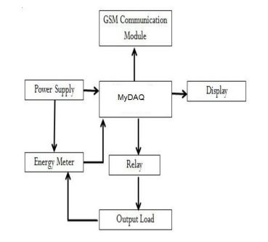

**FLOW CHART:**

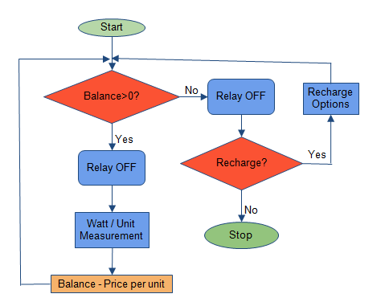

**DESCRIPTION: Power supply Section:**

This section is meant for supplying Power to all the sections mentioned above. It basically consists of a Transformer to step down the 230V ac to 5V ac followed by diodes. Here diodes are used to rectify the ac to dc. After rectification the obtained rippled dc is filtered using a capacitor Filter. A positive voltage regulator is used to regulate the obtained dc voltage.

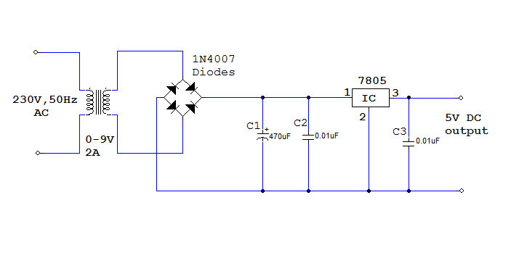

**Relay Section:**

This section consists of an interfacing circuitry to switch ON / OFF the system whenever any unhealthy conditions i.e. overload is detected. This circuitry basically consists of a Relay, transistor and a protection diode. A relay is used to drive the 230V devices.

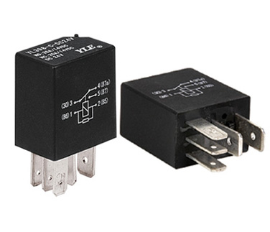

**GSM:**

GSM (Global System for Mobile communication) is a [digital](http://searchcio-midmarket.techtarget.com/definition/digital) mobile telephony system that is widely used in Europe and other parts of the world. GSM uses a variation of time division multiple access ([TDMA](http://searchnetworking.techtarget.com/definition/TDMA)) and is the most widely used of the three digital [wireless](http://searchmobilecomputing.techtarget.com/definition/wireless) telephony technologies (TDMA, GSM, and [CDMA](http://searchtelecom.techtarget.com/definition/CDMA)). GSM digitizes and compresses data, then sends it down a channel with two other streams of user data, each in its own time slot. It operates at either the 900 [MHz](http://searchnetworking.techtarget.com/definition/MHz) or 1800 MHz frequency band

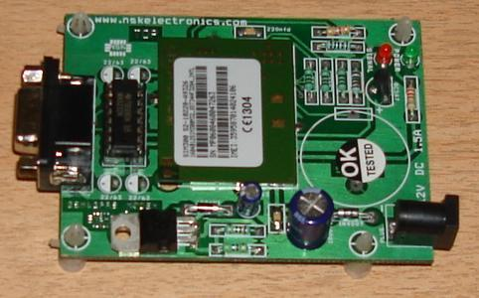

**TRANSFORMER:**

A **transformer** is an electrical device that transfers electrical energy between two or more circuits through [electromagnetic induction](https://en.wikipedia.org/wiki/Electromagnetic_induction). Electromagnetic induction produces an electromotive force within a conductor which is exposed to time varying [magnetic fields](https://en.wikipedia.org/wiki/Magnetic_field). Transformers are used to increase or decrease the alternating voltages in electric power applications.

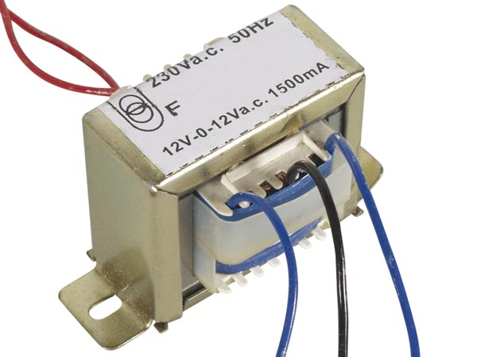

**RESULT:**

The design of Smart Energy meter using GSM technology that can make the users to pay for the electricity before its consumption. In this way, consumers hold credit and then use the electricity until the credit is exhausted. If the available credit is exhausted then the electricity supply is cutoff. An arrangement is also made to intimate the user with the help of GSM communication module when their credit in their balance goes low. This system has been proposed as an innovative solution to the problem of affordability in utilities system. Since a system is being designed, the readings can be continuously recorded. This reduces human labor and at the same time increases the efficiency in calculation of bills for used electricity. Smart energy meters will bring a solution of creating awareness on unnecessary wastage of power and will tend to reduce wastage of power. This module will reduce the burden of energy providing by establishing the connection easily and no theft of power will take place.